# Shopping Shop(Fashion Shop)

Sponsored by

*Under the guidance of*

Guide Name:-**Seema Waghmare ma’am.**



Submitted to

### Department of Commerce

Sinhgad College of Science

**Pune -41**



**Savitribai Phule Pune University**

Partial fulfillment of

SYBBA-CA

Submitted by

### Student’s Name: Om Ramesh Paygude.

**Seat No. 1949.**

**Student’s Name: Prastant Girish Sahani.**

**Seat No. 2142.**

# *Certificate*

This is to certify that the project entitled “________________________________________ ” which is being submitted herewith for the partial fulfillment of award of the SY BBA-CA of Savitribai Phule Pune University. This is the result of the original work completed by ____________________________ under my supervision and guidance and to the best of my knowledge and belief the work embodied in this project has not formed the earlier the basis for the award of any Degree or Diploma or other similar title of this or any other University or examining body.

*Date : / / .*

*Place : Pune*

Guide Internal External

Dept of Commerce Examiner Examiner

### 

# *Declaration*

I hereby declare that the project entitled “______________________” completed and written by me has not previously formed the basis for the award of any degree or diploma or other similar title of this or any other university or examining body.

*Date : / /.*

*Place : Pune*

### Student Signature

### 

Acknowledgement

*With deep sense of gratitude and indebtedness, I thank my research guide ______________, Head, Department of Commer(BBA-CA) ______ , and Dr Magan Ghatole Principal, Sinhgad College of Science ,Pune for his /her constant encouragement, inspiring guidance, constructive criticism and valuable suggestions during entire research work. Working with him has been a great joy, which was not at all spoiled by customary formalities and unnecessary fuss about rules and regulations.*

Students Signature

**Table of Contents (Fashion Shop)**

|  |  |  |
| --- | --- | --- |
| **Sr.** | **Contents** | **Page no** |
| 1. | Company Profile (optional) | - |
| 2. | Introduction to the project | 6 to 7 |
| 3. | Scope of Work | 8 |
| 4. | Feasibility Study | 9 to 10 |
| 5. | Need for System | 11 |
| 6. | Operating Environment - Hardware and Software | 12 |
| 7. | Proposed System  7.1 Objectives to be fulfilled  7.2 User Requirements  7.3 System Features  D.F.D.'s and ER's | 13 to 14 |
| 8. | User Interfaces | 15 to 16 |
| 9. | Design of Output screens and reports | 17 to 25 |
| 10. | Drawbacks and Limitations | 26 |
| 11. | Future Enhancement | 27 to 28 |
| 12. | Conclusions | 29 |
| 13. | Bibliography | 30 |
|  |  |  |

N.B.: Above titles of chapter and points are for reference only. Use appropriate words / headings in your report.

**Introduction to the project:**

The Shopping App Website is a web-based platform designed to provide users with a seamless shopping experience. It incorporates HTML, CSS, and JavaScript to create an interactive and visually appealing interface. The website is structured into multiple pages, each serving a specific purpose to enhance user engagement and facilitate efficient navigation.

**Key Features:**

User Authentication: Secure login and registration functionalities for personalized user accounts.

**Responsive Design:** A responsive layout ensures optimal viewing across different devices and screen sizes.

**Product Catalog:** A comprehensive catalog of products with search and filter options for user convenience.

**Interactive Elements:** Use of JavaScript for interactive elements like image sliders, dropdown menus, and form validation.

**Contact and Support**: Easy access to customer support services for inquiries and assistance.

**Secure Payments:** Integration of secure payment gateways for safe and hassle-free transactions.

**Conclusion:**

The Shopping App Website aims to deliver a user-friendly and engaging shopping experience by combining effective design elements, intuitive navigation, and essential features. It caters to both new and returning users, providing them with a seamless platform to explore products, make purchases, and interact with the brand.

**Scope of Work:**

**1. Introduction:**

The Shopping App Website aims to provide a static representation of a shopping platform using HTML, CSS, and JavaScript with dummy data. The project scope outlines the key functionalities and limitations of the static website.

**2. Objectives:**

Create a visually appealing and user-friendly interface for a fictional shopping app.

Implement basic user authentication (login and registration) using dummy data.

Display a catalog of products with dummy information, including images, descriptions, and prices.

Develop static pages for home, product listing, product details, contact us, and payments.

Incorporate interactive elements like image sliders, dropdown menus, and form validation using JavaScript.

Showcase responsiveness across different devices and screen sizes for optimal user experience.

**Feasibility Study:**

**1. Technical Feasibility:**

Tools and Technologies: Using HTML, CSS, and JavaScript for frontend development is highly feasible as these technologies are widely supported and well-documented.

**Scalability:** The website's static nature with dummy data ensures it can handle a reasonable amount of traffic without significant performance issues.

**Integration:** Integrating basic functionalities like user authentication, product display, and contact forms using dummy data is technically feasible within the chosen technologies.

**2. Economic Feasibility:**

**Costs:** The development costs for a static website using HTML/CSS/JS are relatively low compared to dynamic websites requiring server-side scripting and database integration.

**Maintenance:** Ongoing maintenance costs are minimal as there are no complex backend systems or databases to manage.

**Scalability:** As the website is static, scalability costs are minimal unless major redesigns or feature enhancements are planned in the future.

**3. Operational Feasibility:**

**Ease of Use:** The website's static design and simulated functionalities make it easy for users to navigate and understand.

**Training:** Minimal training is required for users as the website's interface is intuitive and familiar to most online shoppers.

**Support:** Since it's a static site with no real-time interactions, ongoing support needs are minimal.

**4. Schedule Feasibility:**

**Development Time:** Given the simplicity of the project's scope (static website with dummy data), development time is relatively short.

**Testing:** Testing efforts are focused on ensuring proper display across devices, basic functionality testing, and form validation.

**Deployment:** Deployment can be done quickly on various hosting platforms, considering the static nature of the website.

**5. Legal and Ethical Feasibility:**

**Data Privacy:** Since the website uses dummy data and doesn't collect real user information, data privacy concerns are minimal.

**Compliance:** Ensure compliance with relevant laws and regulations regarding website content, accessibility, and data handling, even with dummy data.

**Conclusion:** The feasibility study indicates that developing the Shopping App Website using HTML, CSS, and JavaScript with dummy data is highly feasible from technical, economic, operational, and schedule perspectives. The project requires minimal resources, has low maintenance costs, and can be deployed quickly. However, it's important to ensure legal compliance and ethical considerations throughout the development process.

**Need for System:**

The Shopping App Website is a strategic investment for businesses looking to meet the evolving needs of online shoppers, enhance customer engagement, increase sales, and maintain a competitive edge in the digital marketplace. By addressing customer needs and market demands, the system fulfills a crucial role in modern retail operations and contributes to business growth and success.

**Operating Environment - Hardware and Software:**

**Hardware Requirements:**

**Processor:** Intel Core i3 or equivalent

**RAM:** 2GB or higher

**Storage:** Minimum 10GB HDD

**Network Interface:** Ethernet or Wi-Fi for internet connectivity

**Software Requirements:**

**Server-Side Software:**

**Operating System:** Linux (e.g., Ubuntu Server) or Windows Server

**Web Browsers:** Google Chrome, Mozilla Firefox, Safari, Microsoft Edge (latest versions)

Text Editor or Integrated Development Environment (IDE) for coding (e.g., Visual Studio Code, Sublime Text)

**Frontend Technologies:**

**HTML5:** Markup language for structuring web pages

**CSS3:** Styling language for designing web page layouts and visual elements

**JavaScript**: Programming language for client-side interactions, form validation, and dynamic content

**Proposed System**

**\* Objectives to be Fulfilled:**

Create an intuitive and visually appealing e-commerce platform for online shopping.

Provide a seamless user experience with easy navigation and interactive elements.

Implement basic user authentication for account management (login, registration).

Display a catalog of products with detailed information and search/filter options.

Enable users to view product details, add items to cart, and proceed to checkout.

Incorporate secure payment processing with multiple payment options.

Develop a responsive design for optimal viewing across devices and screen sizes.

Provide contact support and FAQs for user assistance and inquiries.

**\* User Requirements:**

**End Users (Shoppers):**

Ability to register for a new account or log in with existing credentials.

Browse through a variety of products with images, descriptions, and prices.

Search for specific products or filter by categories and attributes**.**

View detailed product information, including specifications, reviews, and ratings.

Add products to a shopping cart for later purchase or proceed to checkout.

**\* System Features:**

**User Authentication:**

Login and registration functionality for users.

Forgot password feature for account recovery.

**Product Catalog**:

Display products with images, descriptions, prices, and ratings.

Search and filter options by category, brand, price range, etc.

**Product Details:**

Detailed product pages with specifications, reviews, and related products.

Add to cart functionality for selected products.

**Shopping Cart:**

View and manage items in the shopping cart.

Update quantities, remove items, and proceed to checkout.

**Checkout Process:**

Billing and shipping information collection.

Order summary and confirmation.

**Responsive Design:**

Optimized layout for desktop, tablet, and mobile devices.

Ensure consistent user experience across different screen sizes.

**Contact Support:**

Contact form for user inquiries and feedback.

**User Interfaces:**

1. **Login/Register Page:**
   * **Login Form:** Input fields for username/email and password with a "Login" button.
   * **Registration Form:** Input fields for name, email, password, and confirm password with a "Register" button.
2. **Home Page:**
   * **Header:** Logo, navigation menu, and user profile/account options.
   * **Featured Products:** Carousel/slider displaying featured products with images, titles, and prices.
   * **Footer:** Links to important pages (About Us, Contact Us, Terms & Conditions), social media icons, and copyright information.
3. **Product Listing Page:**
   * **Filters:** Sidebar or dropdown filters for refining product listings by category, price range, brand, etc.
   * **Product Cards:** Grid or list view of products with thumbnail images, titles, prices, and quick view/add to cart options.
4. **Product Details Page:**
   * **Product Image:** Large image of the product with zoom-in feature and additional images carousel.
   * **Product Information:** Details such as product name, description, price, ratings, reviews, specifications, and availability.
   * **Add to Cart:** Button to add the product to the shopping cart with quantity selection.
   * **Related Products:** Section showing related or recommended products based on the current selection.
   * **Billing Information:** Form fields for entering billing/shipping details, including name, address, contact information, and payment method selection.
   * **Order Summary:** Overview of items in the cart, subtotal, shipping details, and total amount payable.
5. **Contact Us Page:**
   * **Contact Form:** Input fields for name, email, message, and a "Send" button for user inquiries..

These user interfaces should follow best practices in web design, including responsive layouts for mobile devices, intuitive navigation, clear calls-to-action, and visually appealing graphics and typography. Testing and optimizing the interfaces for usability and accessibility are also essential for a successful shopping app website.

**Design of Output screens and reports:**

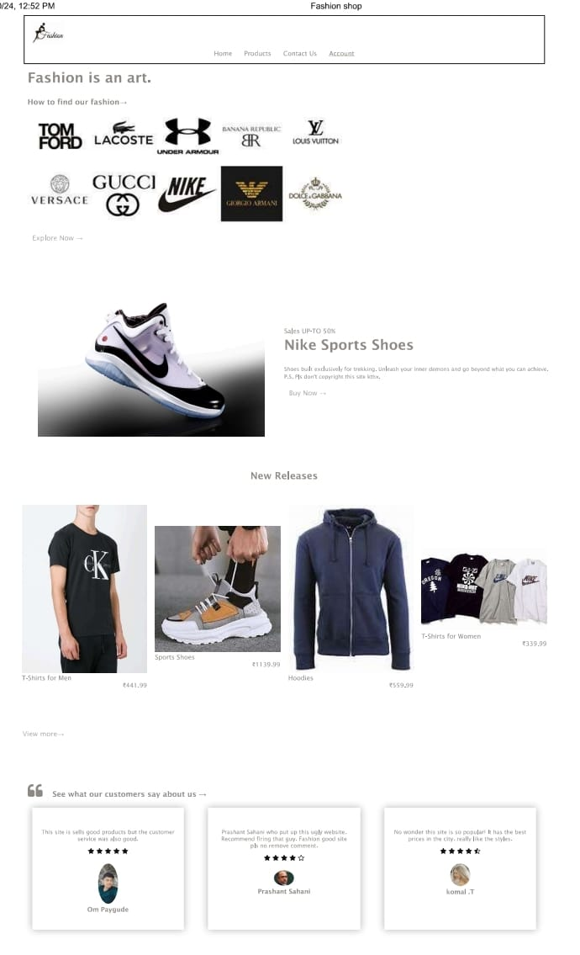

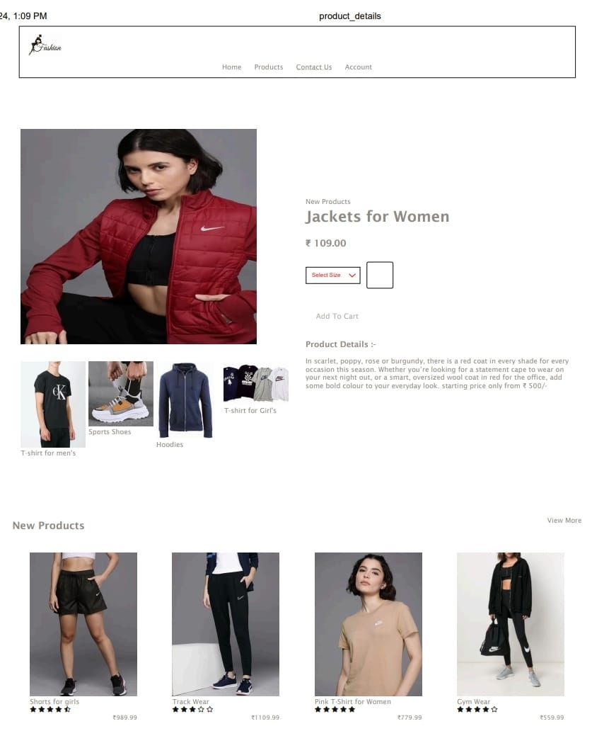

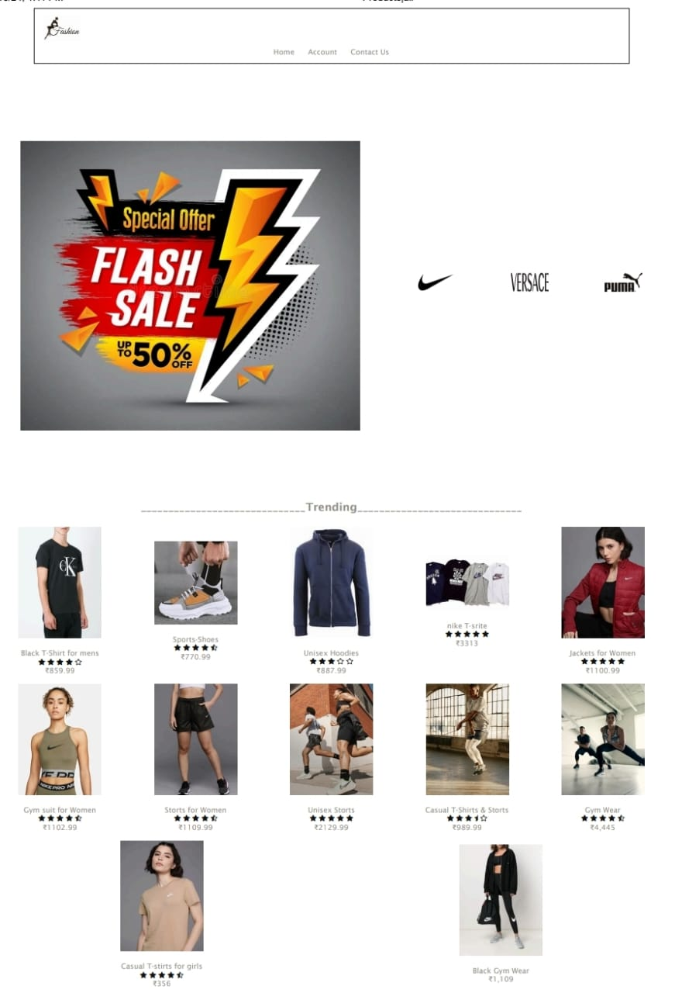

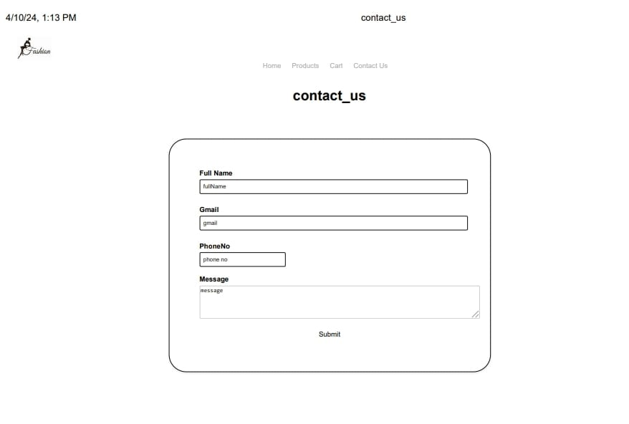

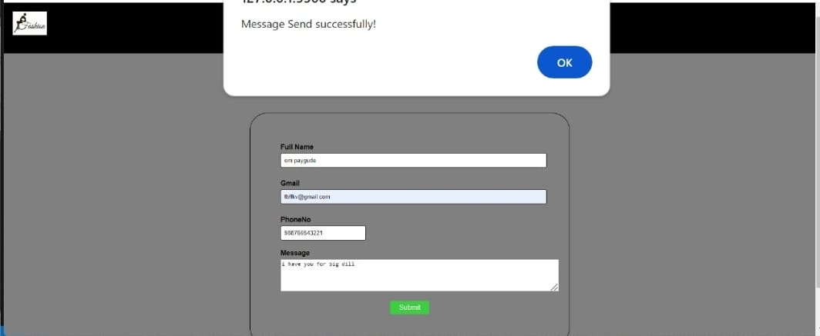

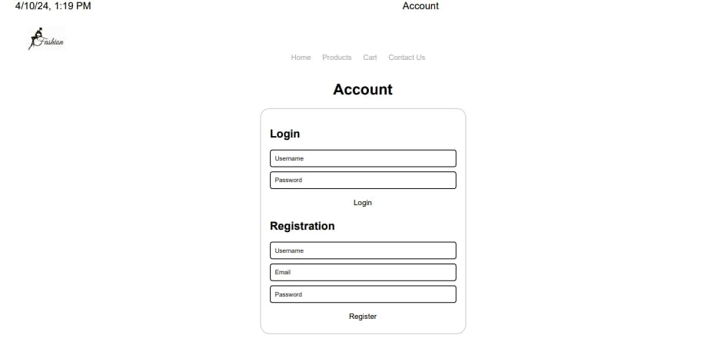

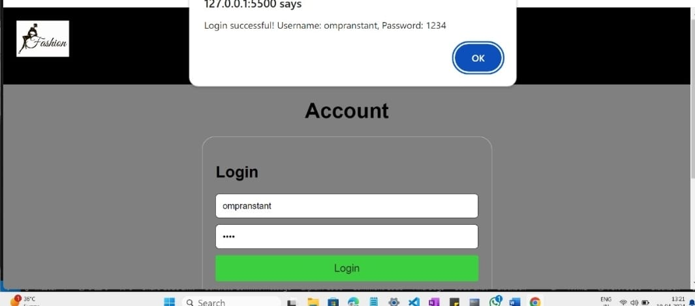

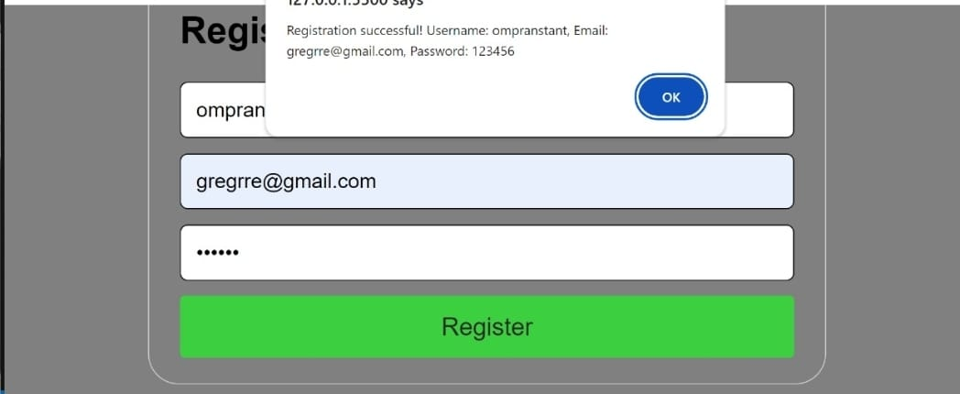

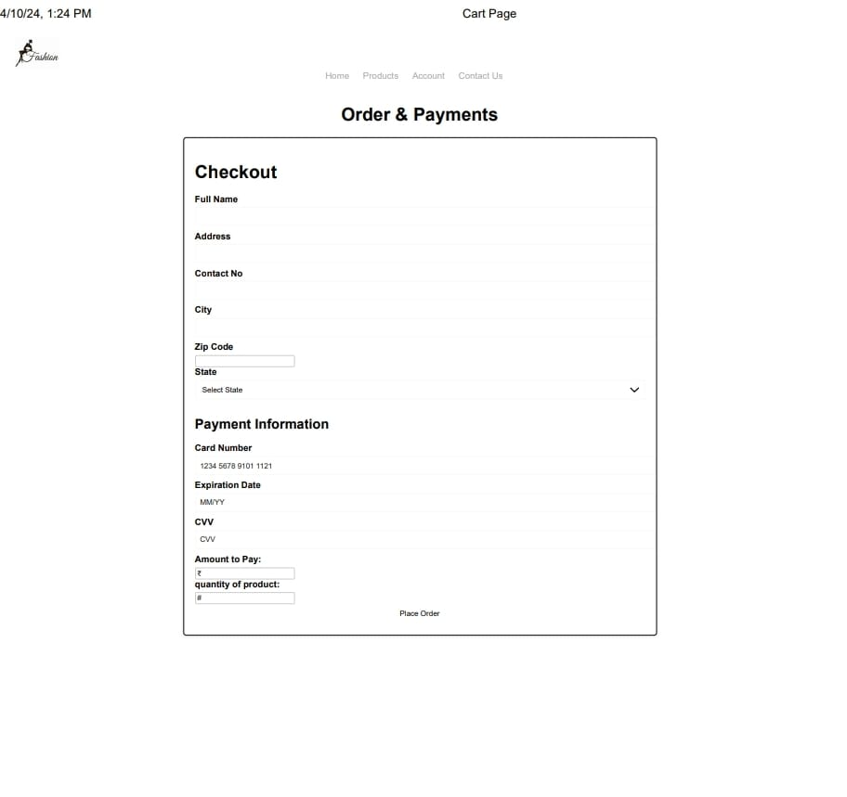

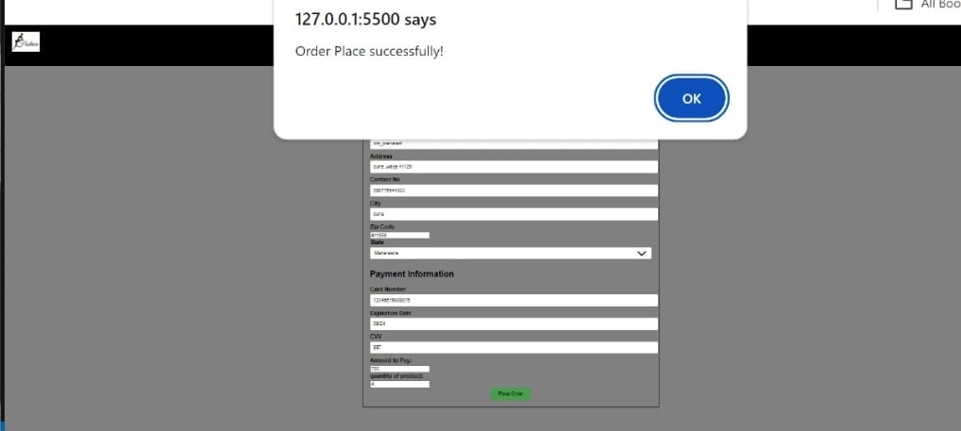

**Drawbacks and Limitations :**

1. **Limited Personalization:** Static shopping websites with dummy data lack personalized recommendations and user-specific content, which can affect user engagement and conversion rates.
2. **No Real-Time Interactions:** Since the website is static, there are no real-time interactions such as live chat support or dynamic updates based on user actions, leading to a potentially less engaging experience.
3. **Scalability Challenges:** Static websites may face scalability challenges when handling a large number of concurrent users or frequent updates, requiring manual intervention and potential downtime during maintenance.
4. **Limited Dynamic Content:** Dynamic content such as real-time inventory status, price fluctuations, or personalized recommendations cannot be provided effectively on a static website, impacting user experience and relevancy.
5. **Complexity of Updates:** Making updates or changes to product listings, pricing, or promotions on a static website can be time-consuming and manual, especially if there are a large number of products or categories.
6. **Inability to Capture User Data:** Static websites may not capture comprehensive user data or behavioral analytics, limiting insights into customer preferences, browsing patterns, and conversion funnels.
7. **Dependency on Frontend Technologies:** The functionality and performance of the website depend heavily on frontend technologies like HTML, CSS, and JavaScript, which may not provide advanced features or real-time data processing capabilities.
8. **Integration Challenges:** Integrating external systems such as payment gateways, inventory management tools, or customer relationship management (CRM) software can be more challenging on a static website compared to dynamic platforms.
9. **Limited User Interaction:** Static websites may lack interactive elements such as product customization options, user-generated content (e.g., reviews, ratings), or social sharing features that enhance user engagement and social proof.
10. **Less Flexibility for Marketing Campaigns:** Running dynamic marketing campaigns, A/B testing, or targeted promotions based on user behavior or demographics is more challenging on a static website without advanced analytics and personalization capabilities.

**Future Enhancement:**

1. **Dynamic Content Integration:** Integrate dynamic content elements such as real-time inventory updates, pricing adjustments based on demand, and personalized product recommendations using machine learning algorithms. This enhances user engagement and encourages repeat visits.
2. **Advanced User Authentication:** Implement advanced user authentication features like two-factor authentication (2FA), social media login options, and biometric authentication for enhanced security and user convenience.
3. **Personalized User Experience:** Utilize data analytics and user behavior tracking to create personalized shopping experiences, including customized product recommendations, targeted promotions, and personalized content based on user preferences and past interactions.
4. **Mobile App Development:** Develop a dedicated mobile app for the shopping platform to provide a seamless and optimized experience for mobile users, including features like push notifications, in-app messaging, and mobile-specific promotions.
5. **Enhanced Search and Filtering:** Improve search functionality with advanced search algorithms, autocomplete suggestions, and natural language processing for more accurate and efficient product discovery. Enhance filtering options with attributes like size, color, brand, and user ratings.
6. **Interactive Product Customization:** Allow users to customize products (e.g., apparel, furniture) using interactive tools such as virtual try-ons, 3D product configurators, and customization options for colors, sizes, and designs.
7. **Social Commerce Integration:** Integrate social commerce features, allowing users to share products on social media platforms, add social proof elements (e.g., user reviews, ratings), and enable social login options for a seamless social shopping experience.
8. **Internationalization and Localization:** Expand the platform's reach by adding support for multiple languages, currencies, and international shipping options to cater to a global audience and increase market penetration.
9. **Blockchain Integration:** Explore blockchain technology for secure payment processing, transparent supply chain management, and authentication of product authenticity, enhancing trust and security for both users and sellers.

These future enhancements can elevate the shopping app website to a more advanced and competitive platform, offering innovative features, personalized experiences, and seamless interactions for users, ultimately driving growth and success in the e-commerce space.

**Conclusions:**

1. **Scalability:** While the current static website with dummy data serves its purpose, future scalability considerations may require transitioning to a dynamic website with real-time data and advanced functionalities to meet growing demands.
2. **Security:** The project's focus on user authentication and secure payment processing addresses basic security needs. Still, ongoing vigilance and updates are necessary to mitigate potential security risks and ensure user data protection.
3. **User Experience:** The user interfaces designed for the website are intuitive and user-friendly, but future enhancements could further improve the user experience with personalized content, dynamic interactions, and mobile responsiveness.
4. **Future Enhancements:** The project sets the foundation for future enhancements such as integrating dynamic content, advanced authentication features, personalized user experiences, and mobile app development to stay competitive and meet evolving user expectations.
5. **Feedback and Iteration:** Continuous feedback from users and stakeholders, coupled with iterative development cycles, will be crucial for refining the website, addressing user needs, and staying aligned with market trends.

Overall, the Shopping App Website project demonstrates the feasibility and potential of creating a successful e-commerce platform. With careful planning, ongoing updates, and strategic enhancements, the website can evolve into a robust and competitive online shopping destination, delivering value to both users and businesses in the digital marketplace.

**Bibliography**

1. **Online Tutorials and Courses**:
   * Websites like Codecademy, freeCodeCamp, and W3Schools offer comprehensive tutorials and courses on HTML, CSS, and web development in general.
2. **Books**:
   * "HTML and CSS: Design and Build Websites" by Jon Duckett
   * "Learning Web Design: A Beginner's Guide to HTML, CSS, JavaScript, and Web Graphics" by Jennifer Niederst Robbins
3. **For Responsive Design**:
   * "Responsive Web Design" by Ethan Marcotte
   * [MDN Web Docs - Responsive Web Design](https://developer.mozilla.org/en-US/docs/Learn/CSS/CSS_layout/Responsive_Design)
4. **Design Inspiration**:
   * Websites like Dribbble and Behance showcase design inspiration for various types of websites, including e-commerce sites.
5. **Online Communities**:
   * Joining communities like Stack Overflow, Reddit's r/webdev, or GitHub can provide opportunities to ask questions, seek advice, and collaborate with other developers.
6. **Browser Developer Tools**:
   * Learning how to use browser developer tools (e.g., Chrome DevTools) can be invaluable for debugging and fine-tuning your website's layout and styling.
7. **Version Control**:
   * Understanding version control systems like Git and platforms like GitHub can help you manage and collaborate on your project more effectively.

**Abstract**

Abstract may have more than one paragraph giving an overview of what problem has been taken with an cover introduction to the broader area of spectrum, importance, proposed approach and results/ performance obtained. Use 1.5 line spacing. Use font Times New Roman size 12 and 1.5 line spacing throughout the text of the report.

All titles should start on the first line of the page without giving any space. Margin layout should be Top, bottom, left and right: 1” margin. No indents for the paragraphs written throughout the report. Always justify the contents.

Page numbers starting from ‘1’ with middle of the page setting has to be given from abstract onwards. No numbering should be given for certificate. Number size is 12, times new roman.